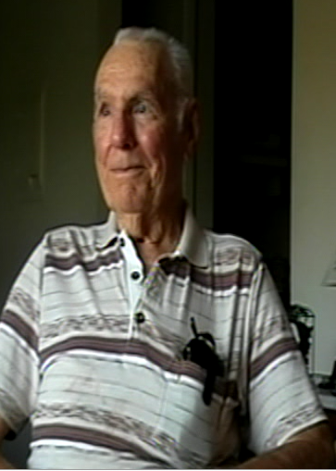
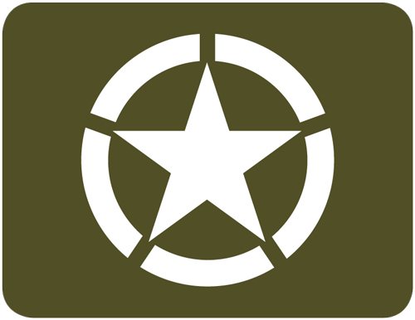
HENRY “PETE” PONTON
U.S SOLDIER
&
D-DAY VETERAN

THE NATIONAL GUARD
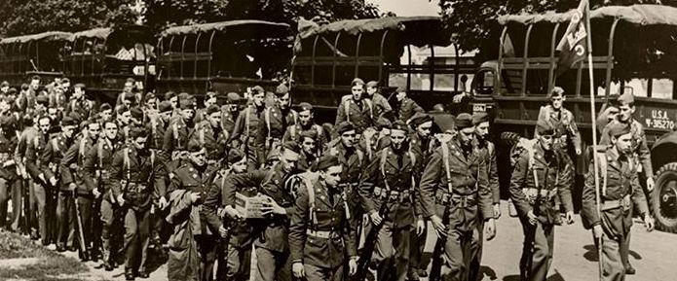
“I Joined the national Guard on June 1st 1940, you had to be 21 to enter, but I entered at 19, since my brother was in the guard since 1934. Every Monday night and a summer camp, I joined for three years, in August I went to New York for three weeks for training. Here I got to know a great deal of the company. Through the three Weeks of training it was cold during the night, I worked in the supply room (Armory) I took care of all the weapons. The captain, Guy Anderson, made me an assistant to the supply sergeant and I was taking care of 45's, M1's, 30 cals, etc. A few of the weapons were from the Great War, the helmets were the same for a while as well. After three weeks I returned home and then I was called into service”

THE LONGEST DAY
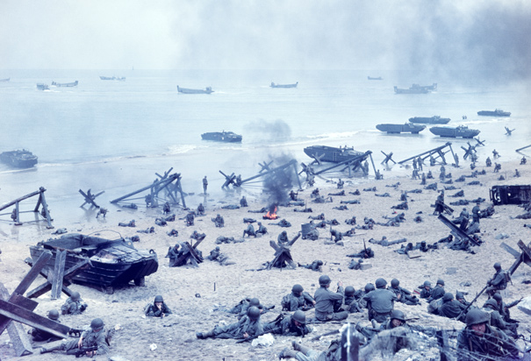
“At the Beginning of June 1944 we were told about the invasion, so we spent time in the barracks until we were given the orders to load onto the ships on 2nd or 3rd of June. There were about 1000 people on the LCI the weather was rainy and windy so we stayed in port. By then it was called off, I did not hear Eisenhower's message, I never thought much about the event at the time. It took us a day and half to cross the channel and we arrived on the Morning of D-Day 9:00 am June 6th. The sight lines are blocked but we knew who was in the first and second waves. I went dow the ladders of the landing craft after we heard all the shots and the shelling, the continuous shelling. we saw a lot of dead and the cliffs in front of them, I did not expect this to happen I did not expect to fight the first day. There was heavy resistance, both Small arms and Artillery. I was not scared when I was on the beach, when looking back I saw the whole battle scene. When I reached top of the cliffs within a half hour I did not see any of the officers during the battle. We did not dig in until that night. There was not much protection on the beach besides a broken down tank, but our main goal was to get off the beach.”

D PLUS ONE
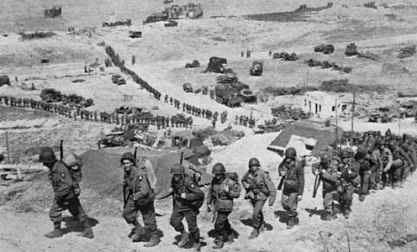
“The first sergent, Elton Shay, got some of the men together they outfitted the tanks to overcome all the obsticles. The Ammunition Train brought the supplies to the front already, right after the battle my mission then became that of a regular the first day they could see German Soldiers. The company was on a night march one guy was hit by a White Phosoherus grenade, a German soldier was wounded and screaming and they released the grenade. St. Lowe was our objective but we never got to St. Lowe until the town fell. There was a counter attack by German Paratroopers However I was not close to this event. That's when I got weapons back from the front and I had to get them back into fighting shape, most were machine guns and rifes. We got a lot of German weapons and we would store most of this.”

POST WAR
“The German Civilian reaction, was that no one wanted to be a Nazi, they were all good Germans.
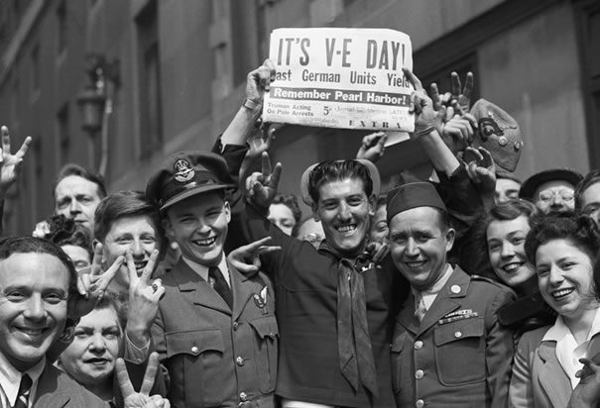
I was stationed in Bermerhauven and I was waiting to go home. I was given no duties at this time There was some talk of having to go to the pacific, I knew about the war from the papers, I then went to another division in a German farming community. I then went to France and we were told we were flying home the orders came in Shipping me back to England. This took 5 days to get back to the US and finally I was able to see the statue of liberty. No one greeted me when I docked and I was discharged after only one month on Oct.28th 1945.”

